[Week 3](https://www.coursera.org/learn/introduction-to-data-engineering/home/week/3)

Architecting the Data Platform

Data Ingestion or Collection Layer

Tools for data ingestion

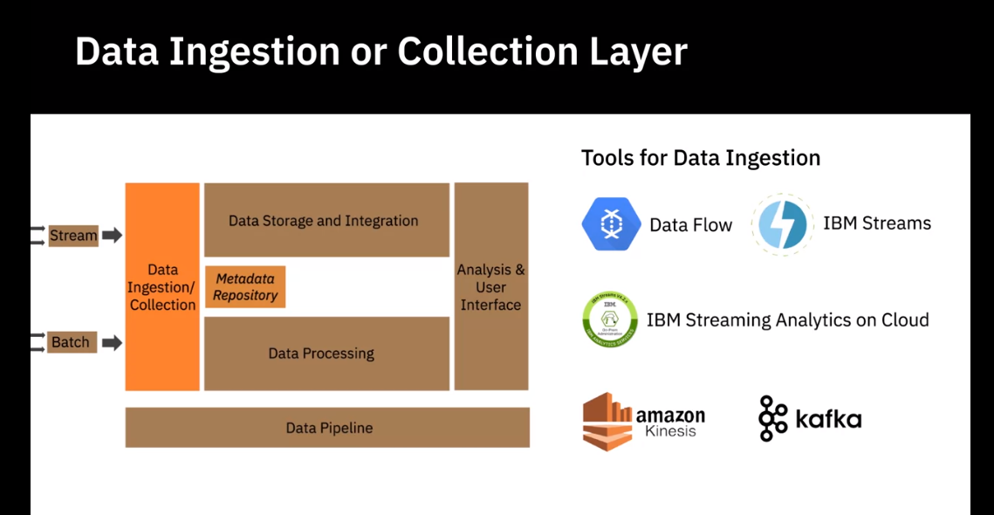

Data Storage Layer

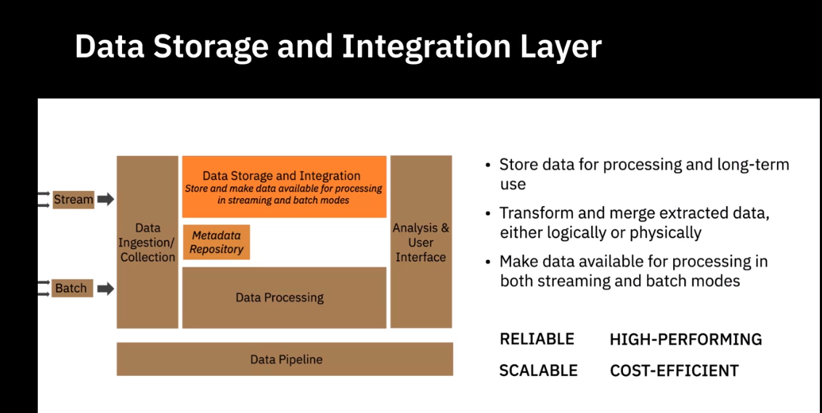

Ralational Databases

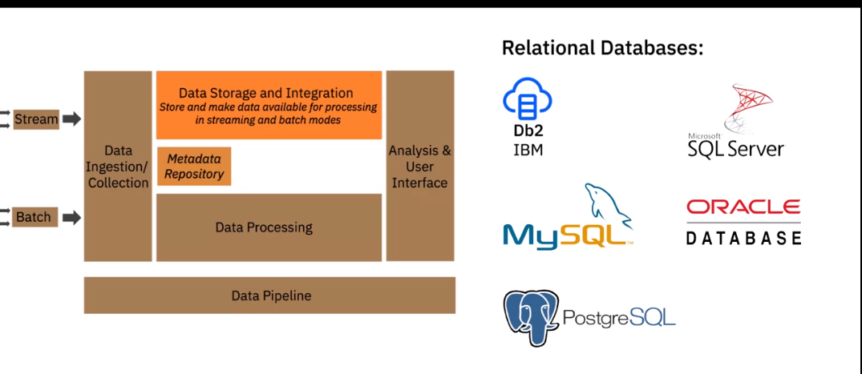

Database as a service

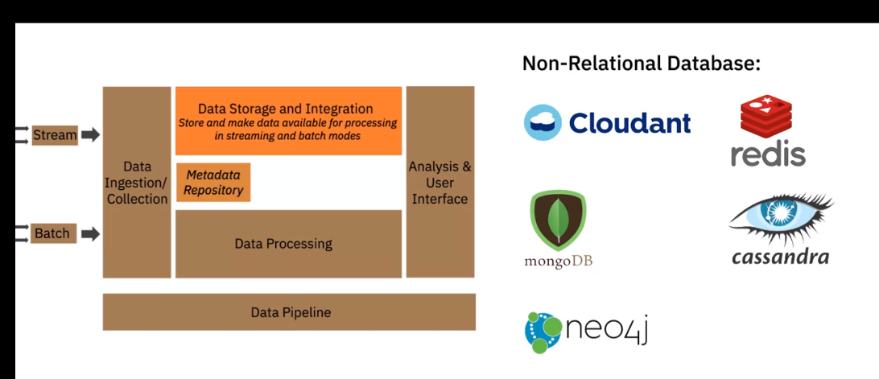

Integration Tools

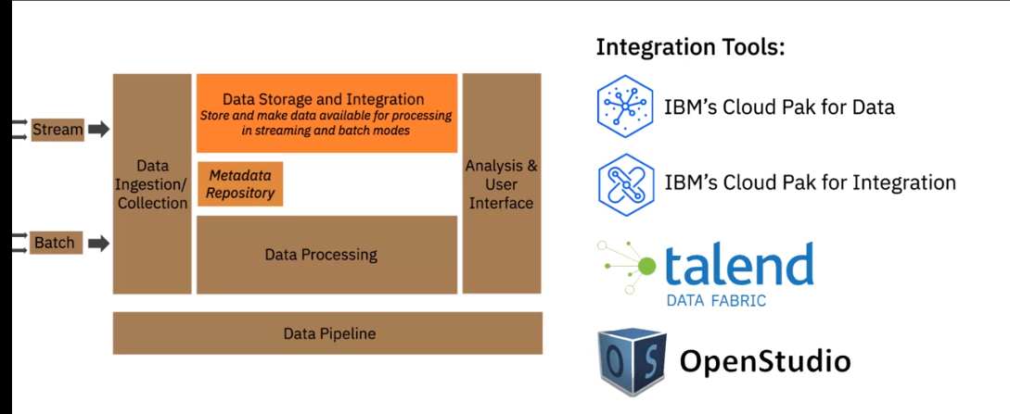

Data Processing Layer

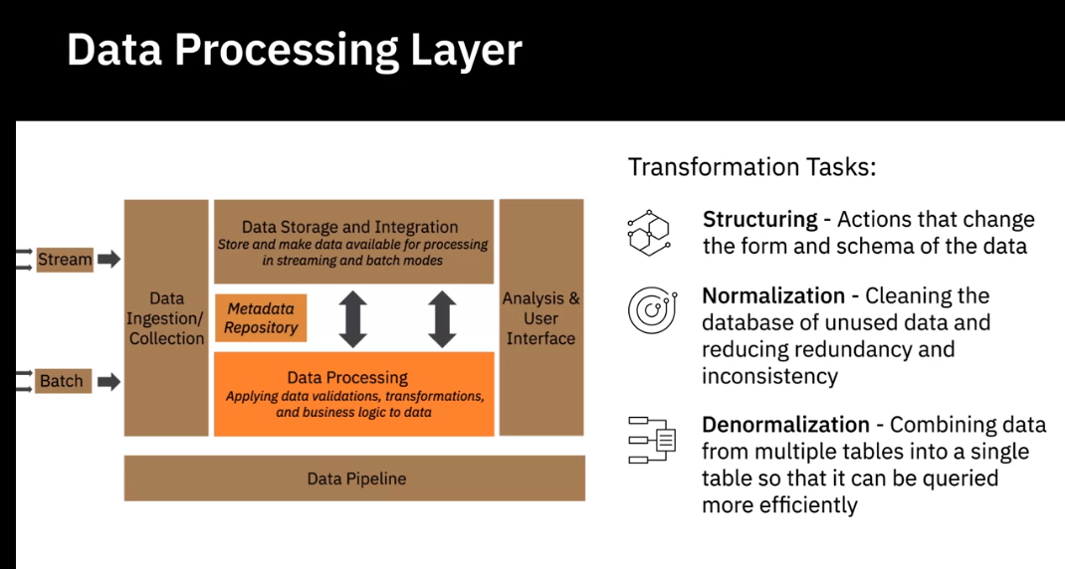

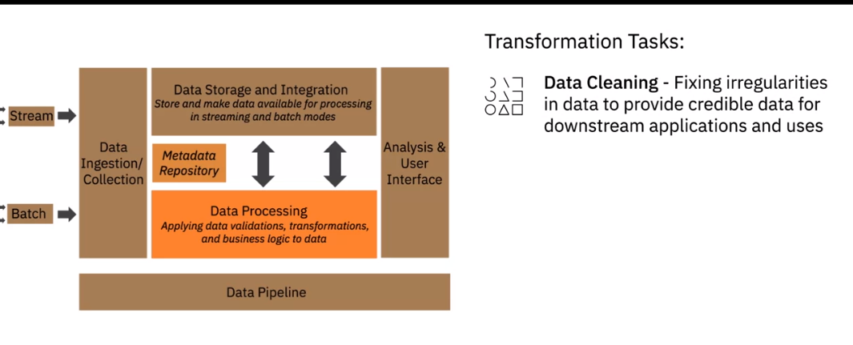

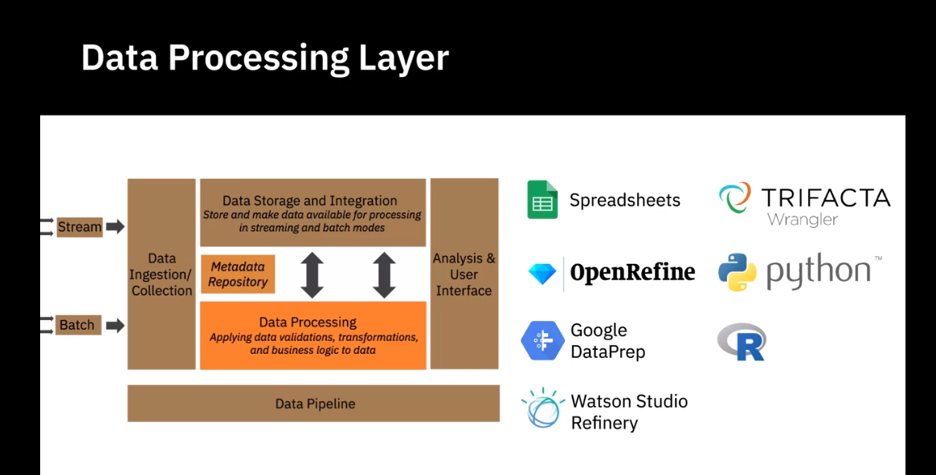

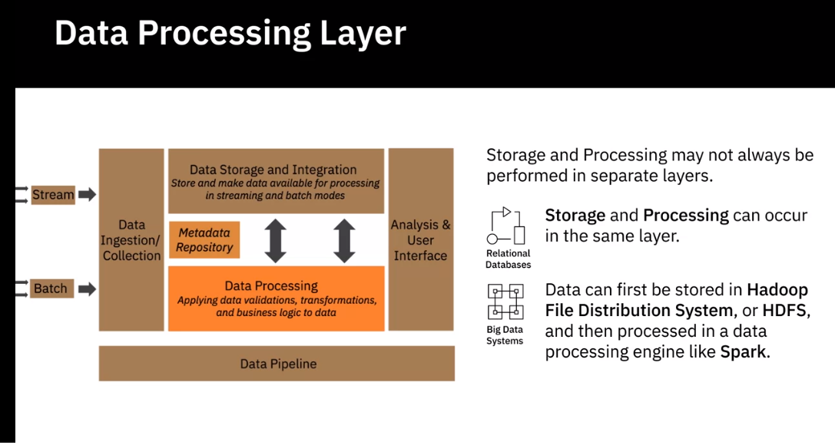

Analysis User Interface Layer

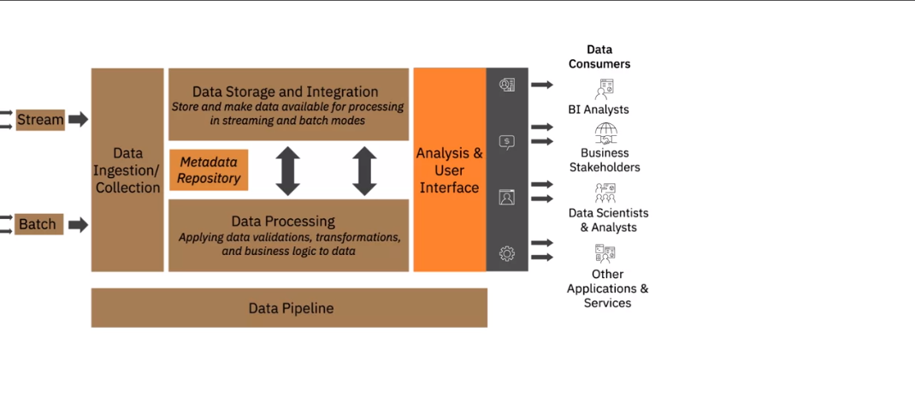

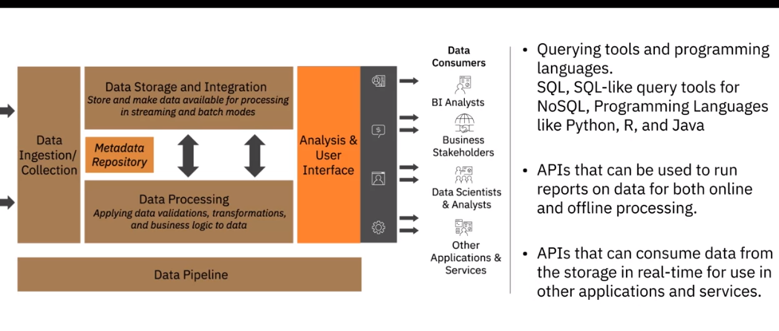

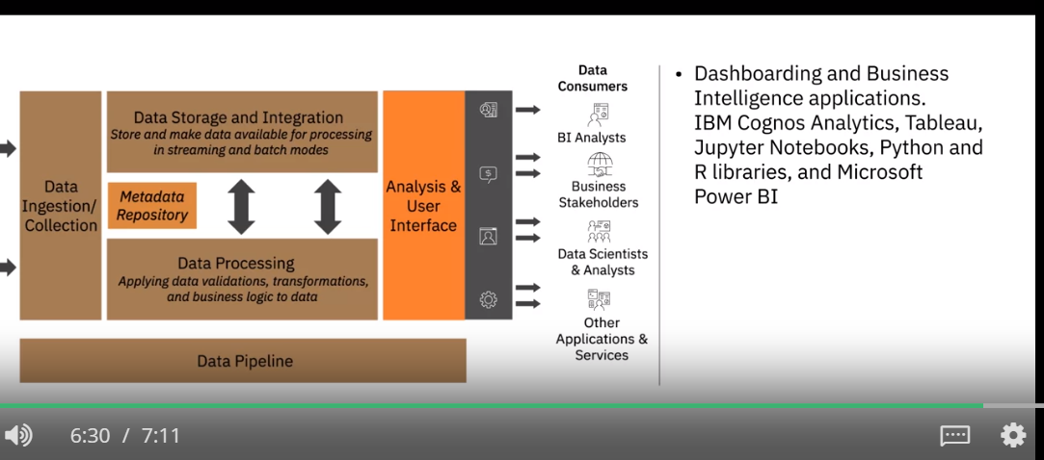

Data Pipeline Layer

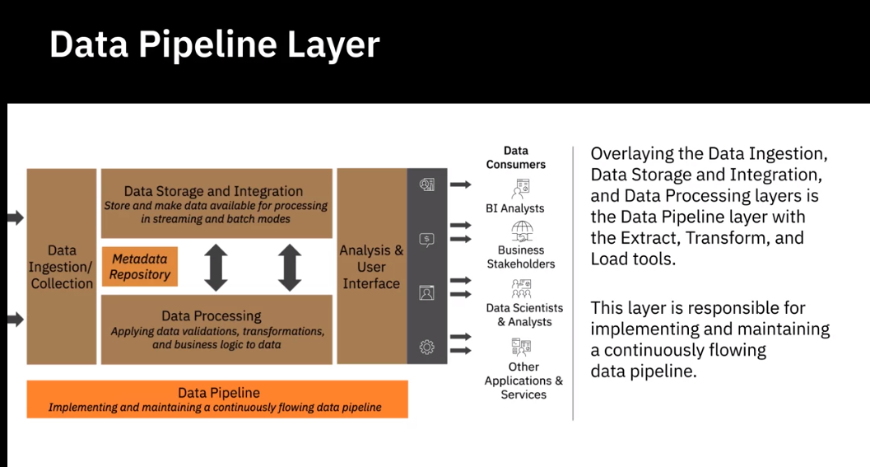

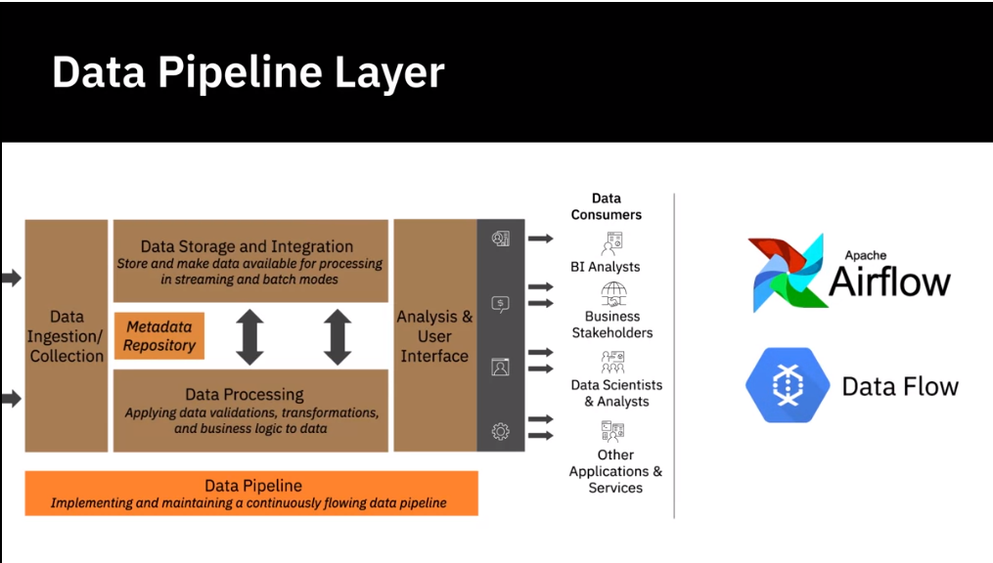

**Factors for Selecting and Designing Data Stores**

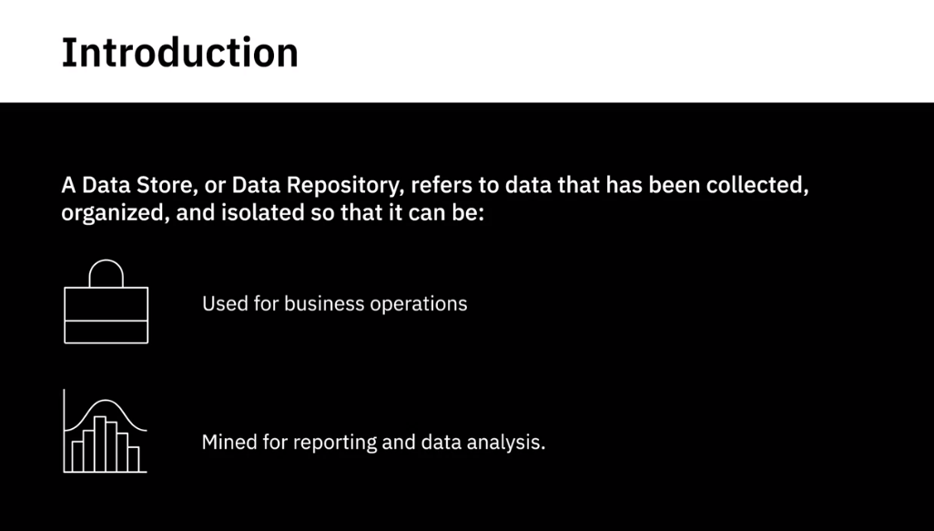

Considerations of designing a data store

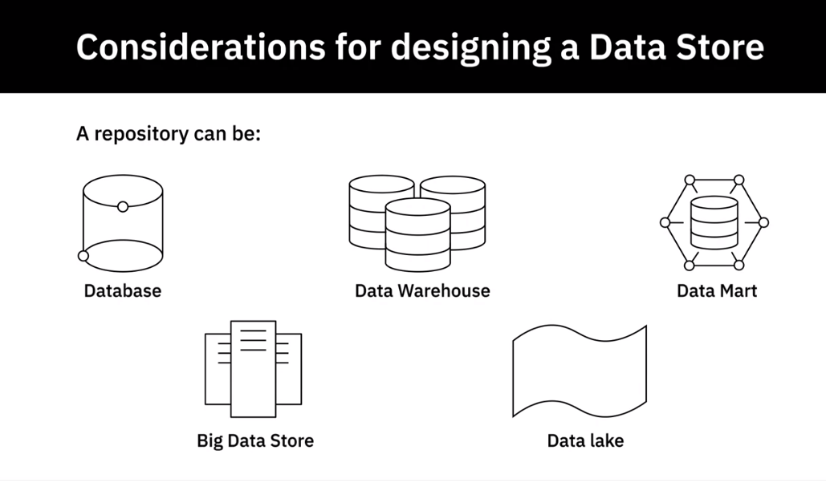

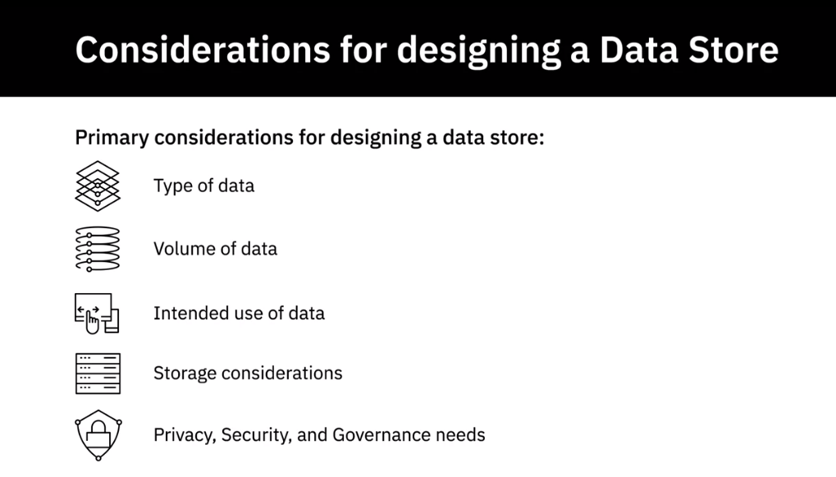

Type of Data

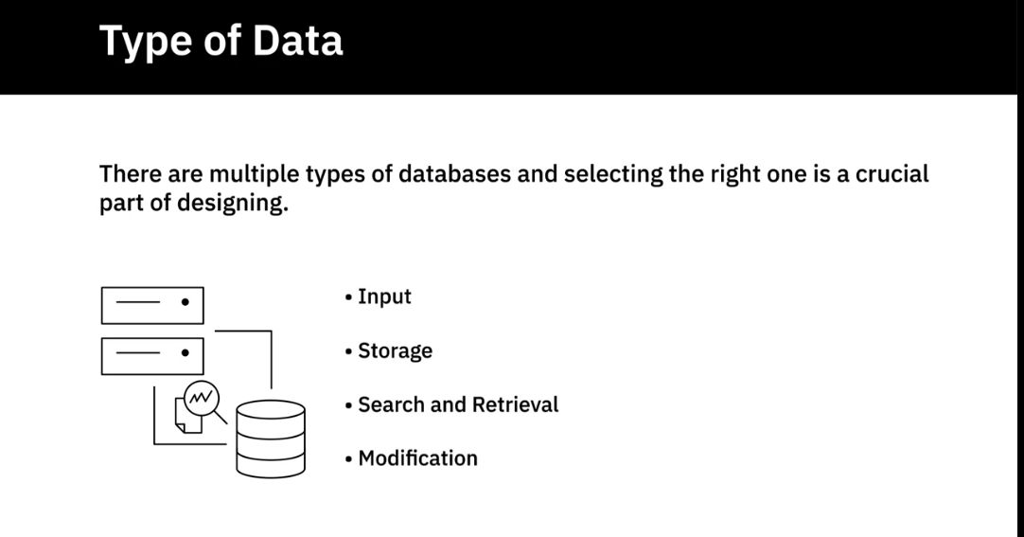

Type of Database

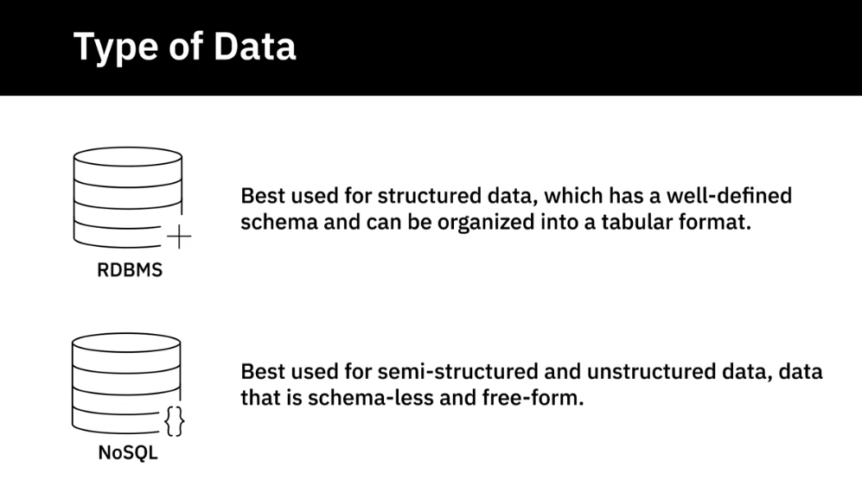

Type of nosql database

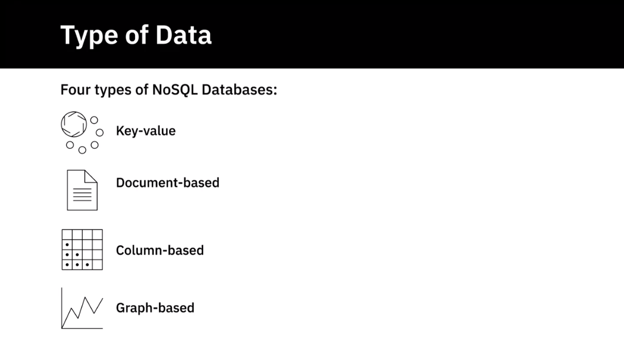

Volume of Data

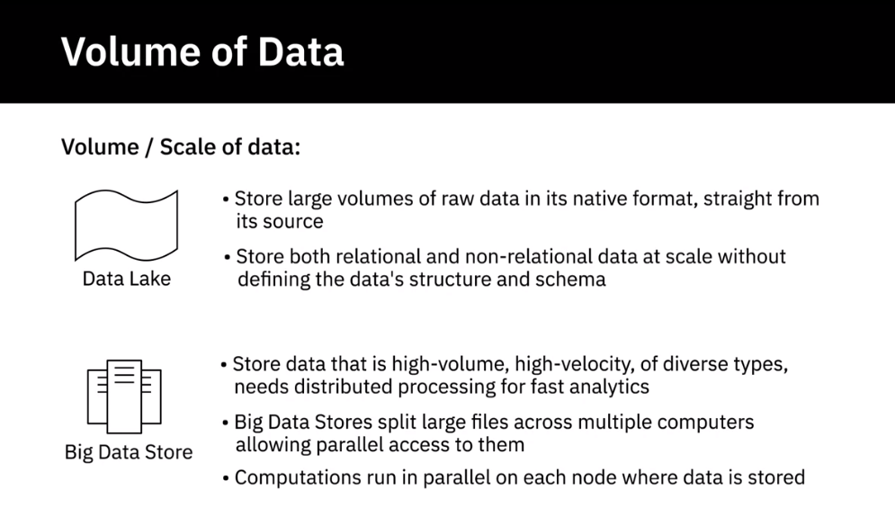

Intended use of Data

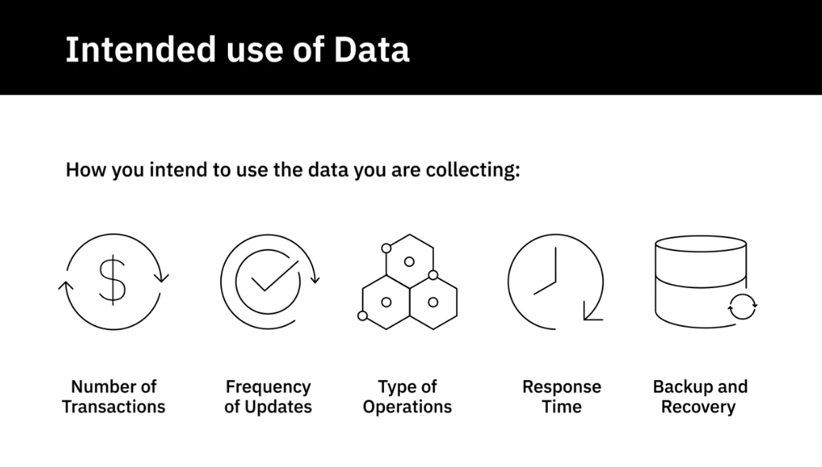

Intended use of Data

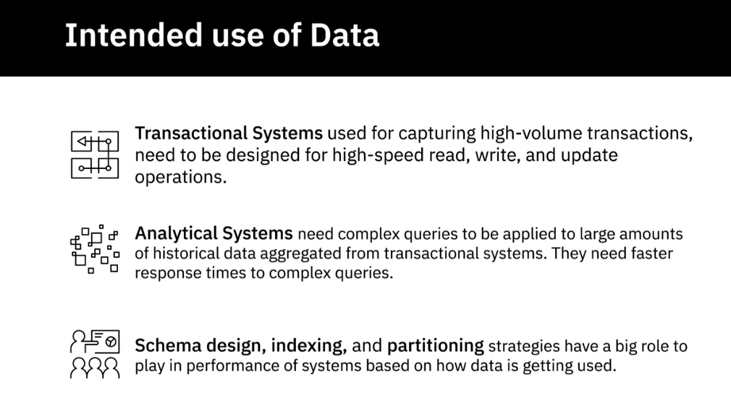

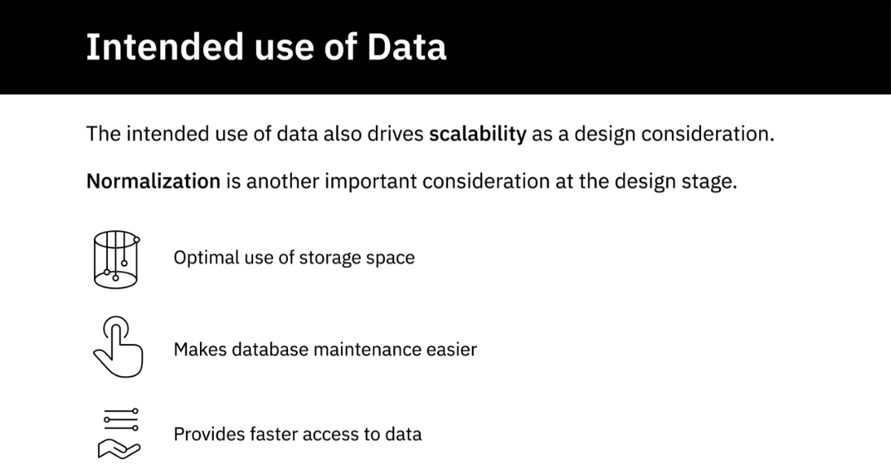

Normalisation: Transactional Data

Storage Considerations

Performance, availability Integrity and recoverability

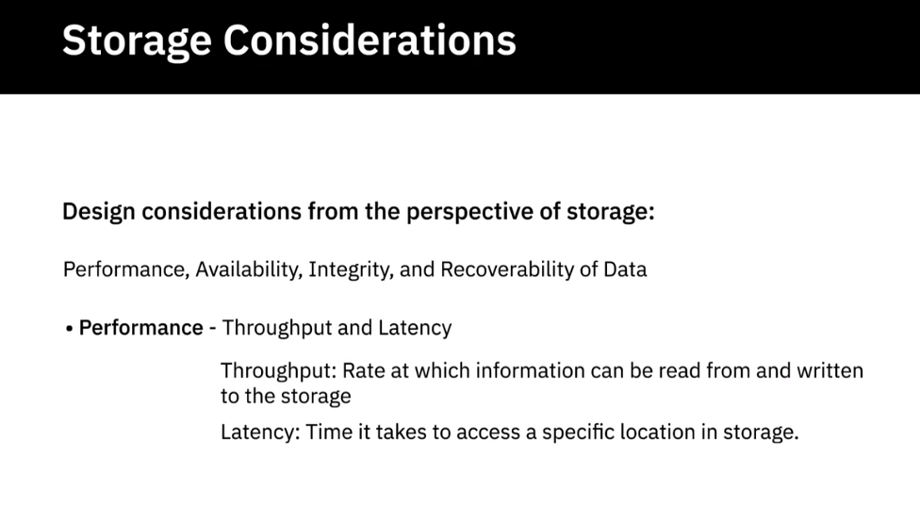

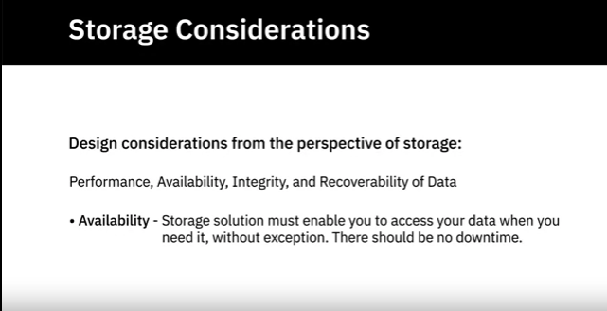

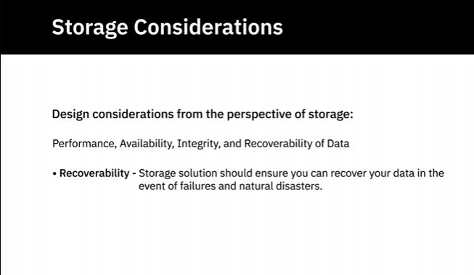

Privacy Security and Governance

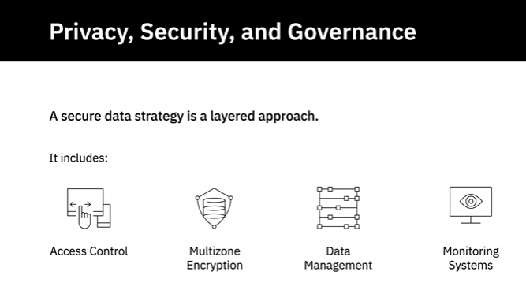

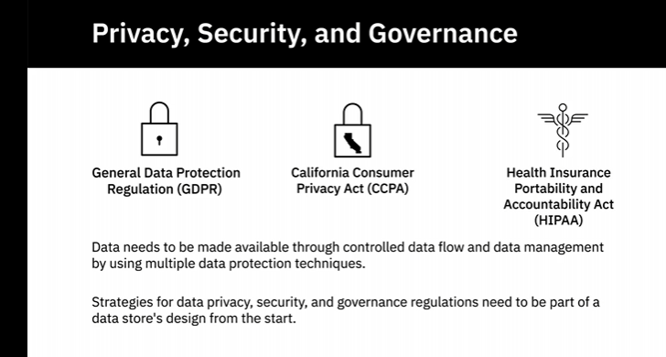

**Security**

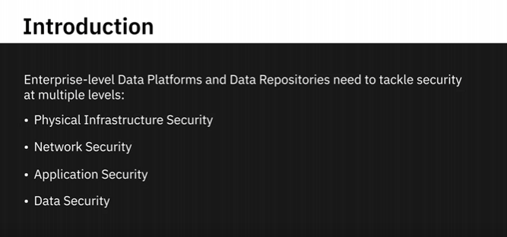

The CIA Triad

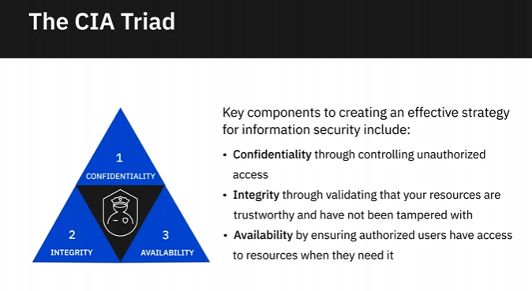

Application

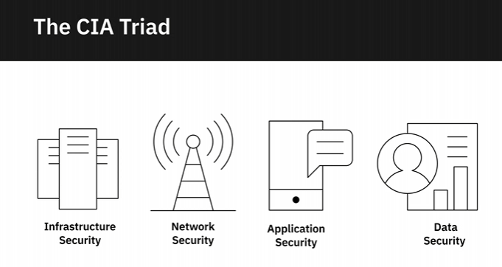

Physical Infrastructure Security

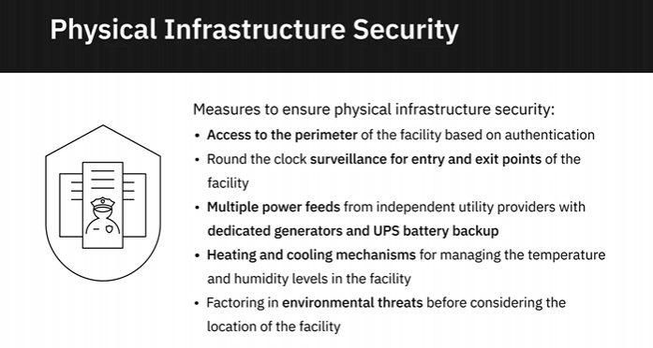

Network Security

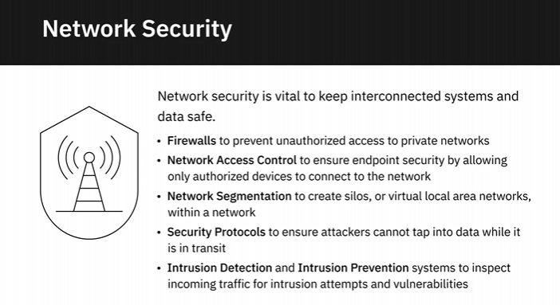

Application Security

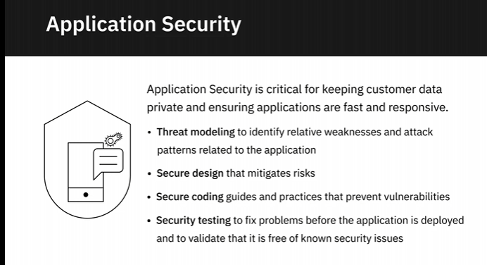

Data Security

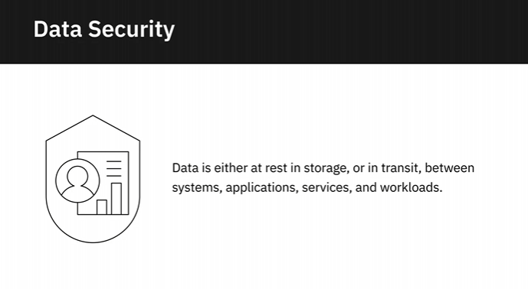

Authentication

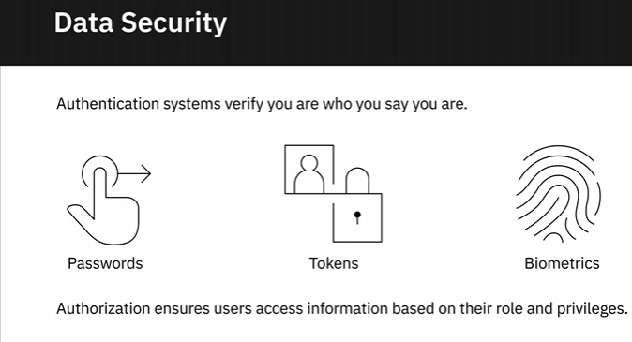

Data at Rest and Data in Transit

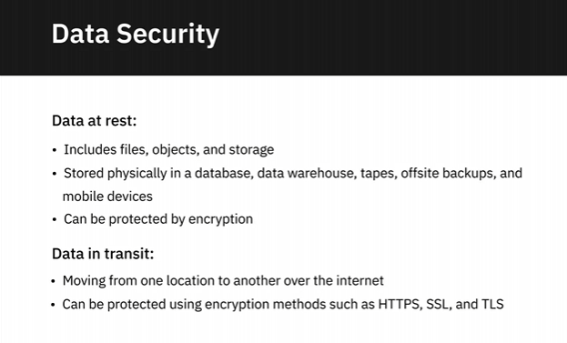

Monitoring and Intelligence

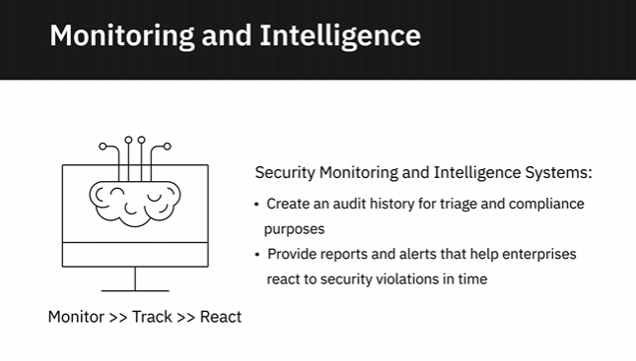

**Viewpoints: Importance of Data Security**

In this video, we will listen

to several data professionals talk about the importance of

data security as it relates to data engineering. So if your data is not secure,

nothing else about it really is going to matter in the long run.

There are many companies who are examples of serious data

breaches, and while that won't necessarily put you out of

business these days, that depends on the size of your

organization somewhat to begin with. If you're a smaller

organization and you lose access to your own data, that's

certainly a potentially company-ending problem. You really

can't understate the importance of data security. It's often

something we think of, oh we'll, harden it after go live or we'll

harden it just before go live. But really it's something that

you have to be thinking about data security along every step

of the way. The importance of security of data can't be stressed enough. A few years

ago, The Economist magazine published an article saying the

world's most valuable resource is no longer oil, but data. So if data is the most valuable

resource an organization has, it needs to be secured and protected. And failure to do so

can have catastrophic consequences. So data security, governance, compliance, these

are not just things that a data engineer needs to worry about. This needs to be an important

part of not just the data architecture, but the entire

organizational processes and every part of the organization

needs to keep on top of these things. We have to make sure

that when we have separate production and non-production

environments that our production data doesn't get unmasked into a

lower environment. There are absolutely data breaches that

can happen that way. We have to think about making sure that

people who have access to production data really need that

access to production data. The important thing is to understand

the security levels and roles for the tool you're using, and

make sure that each user is getting the least privilege

they need in order to do their jobs. It's when we give people

more access that we really open things up to data breaches

and data security problems. Most of the threats to your data

are actually more likely to come from within your organization

than without. It may be exciting, or whatever, to think of

somebody coming from outside of your organization to get to your

data, but most often that threat is going to come from inside your organization. A lot

of the things that we hear about in the data profession are

things like people at prescription drug places

accessing the prescriptions of celebrities. There are things

along those lines that we have to be very careful in

protecting the data. Data is a natural resource these

days, right? The world of Big Data, data is oil, that's our new

natural resource. So it's our job to make sure that that financial aspect of

valuable data is protected and that our organization is

not at risk for being in the news as one of those causing

a data breach or even worse, being put out of business

because of a data breach. I consider part of data

security, the ability to restore my data and the ability to

recover if a particular set of hardware fails. To me, that's

part of security, because if we lose the data because of a

hardware failure, that means we don't have access to the data,

which is part of data security in my own estimation.

## Data Collection and Data Wrangling

**How to Gather and Import Data**

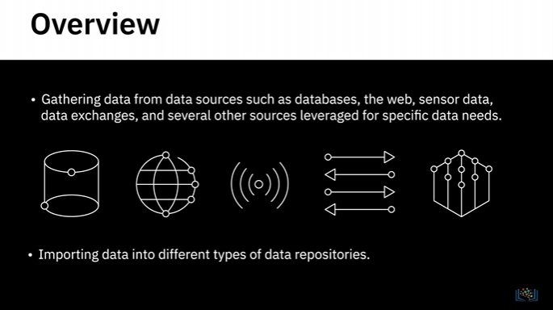

**Using queries to extract data from SQL databases**

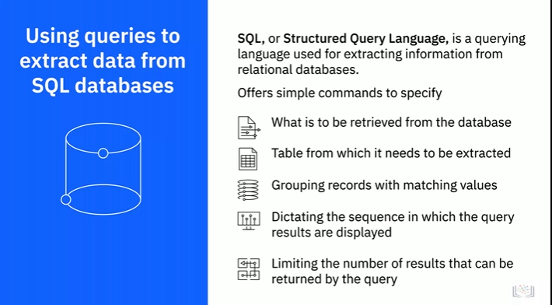

Nosql

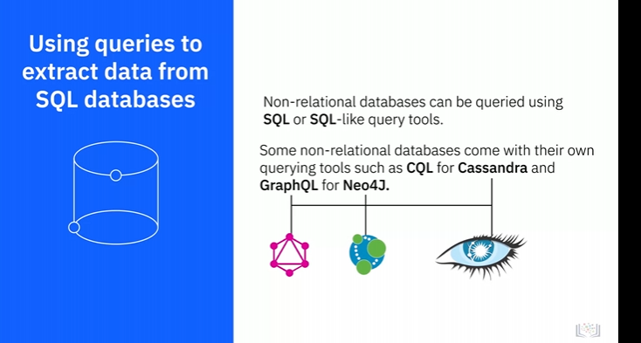

APIs

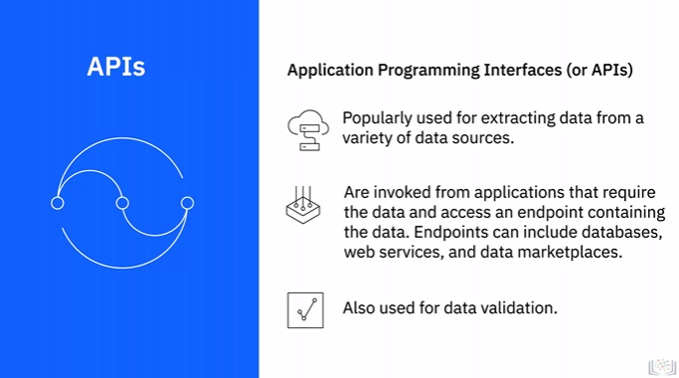

Extracting data from the Web

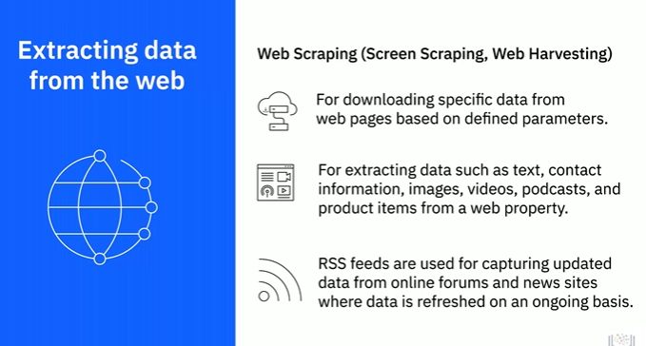

Sensor Data

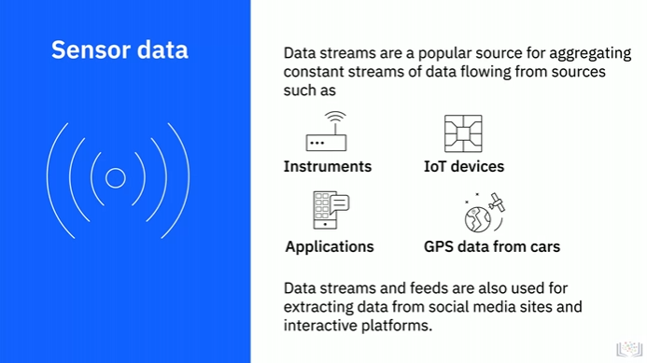

Data Exchanges

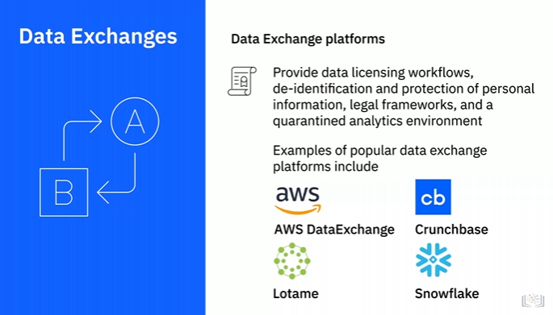

Other Sources

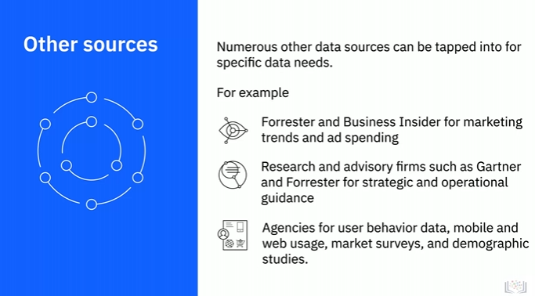

Importing Data

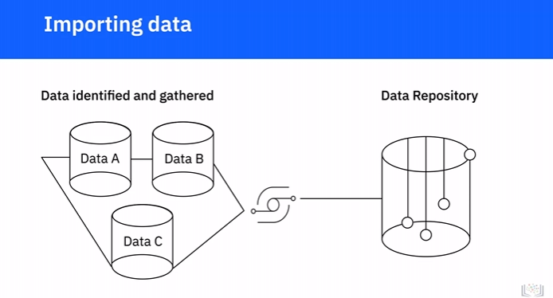

Combined view or single interface

Data type and destination repositories

Dstructured

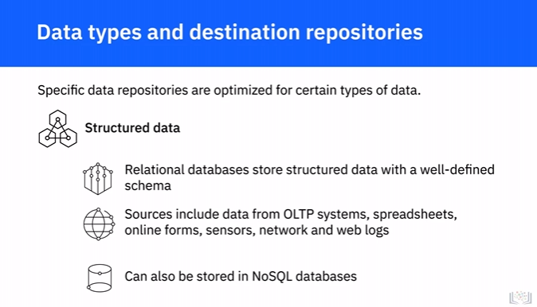

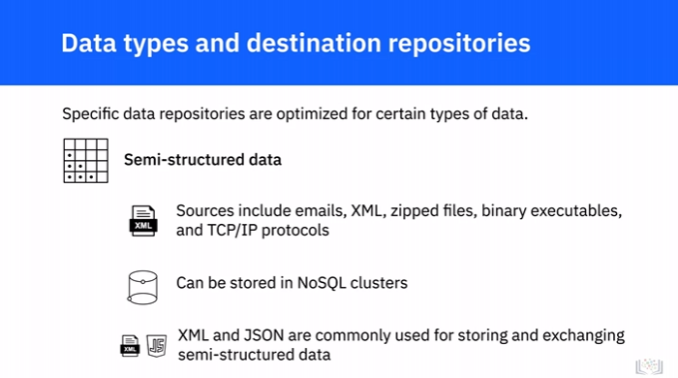

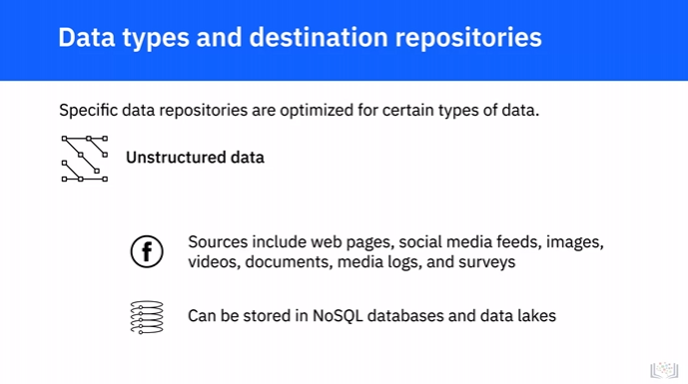

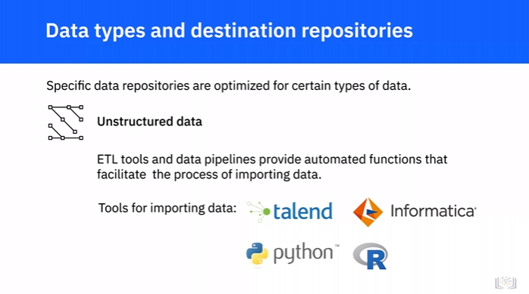

**Data Wrangling**

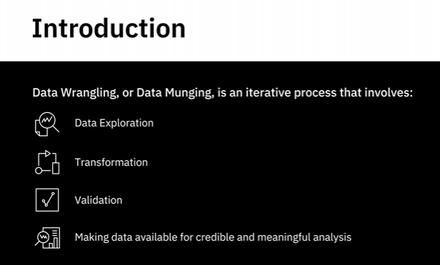

Transformation

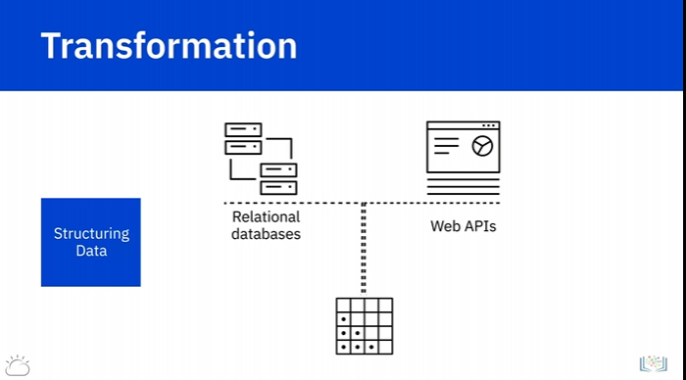

Joins and Unions

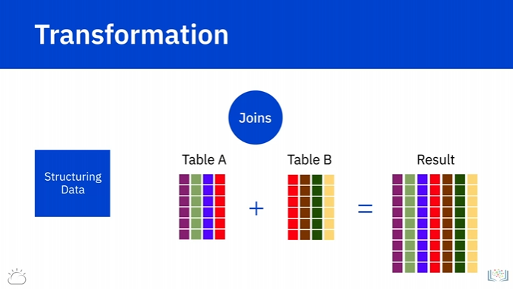

When two tables are joined together, columns from the first source table are combined with

columns from the second source table—in the same row.

So, each row in the resultant table contains columns from both tables.

Unions

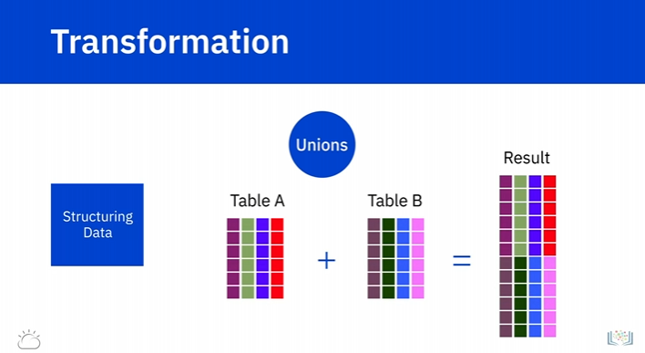

Unions combine rows.

Rows of data from the first source table are combined with rows of data from the second

source table into a single table.

Each row in the resultant table is from one source table or another.

Normalisation and Denormalization

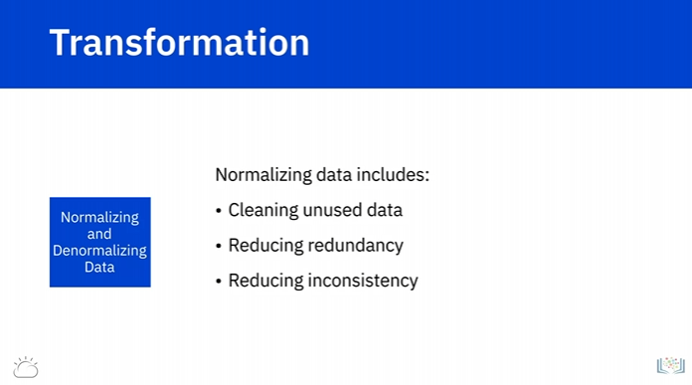

Transformation can also include normalization and denormalization of data.

Normalization focuses on cleaning the database of unused data and reducing redundancy and

inconsistency.

Data coming from transactional systems, for example, where a number of insert, update,

and delete operations are performed on an ongoing basis, are highly normalized.

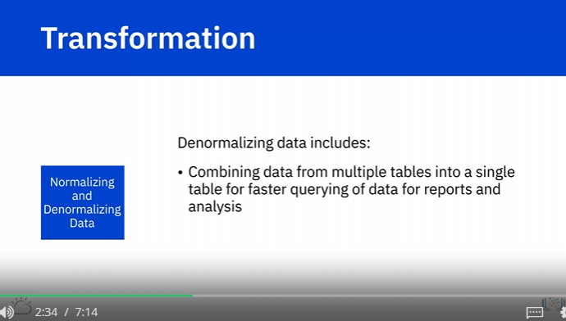

Denormalization is used to combine data from multiple tables into a single table so that

it can be queried faster.

For example, normalized data coming from transactional systems is typically denormalized before running

queries for reporting and analysis.

Cleaning

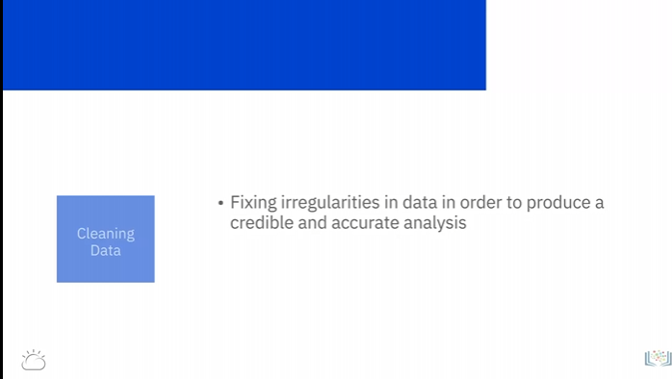

Data cleaning workflow step 1: Inspection

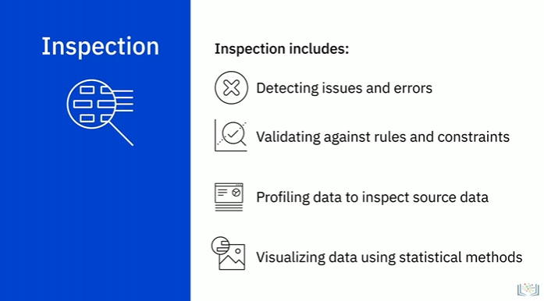

Data profiling

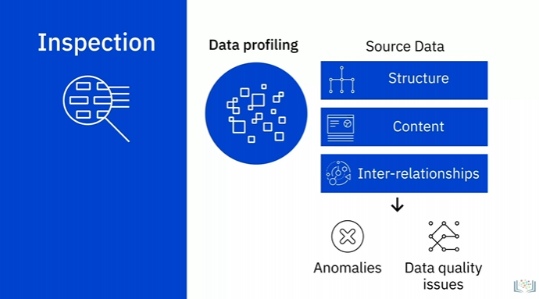

Visualizing the data

Cleaning of Data

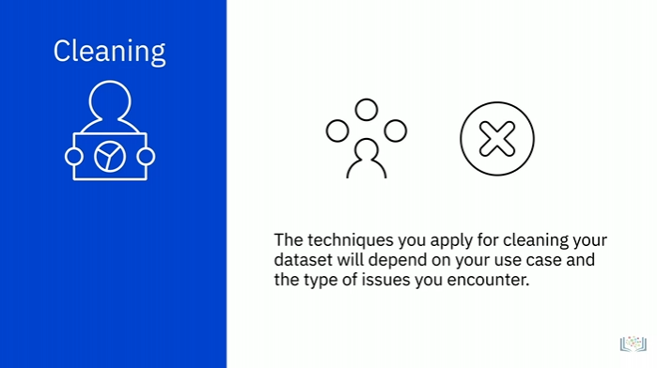

Common Issues

Dealing with Missing Values

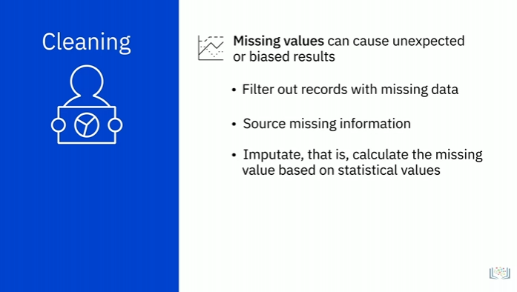

Duplicate Data

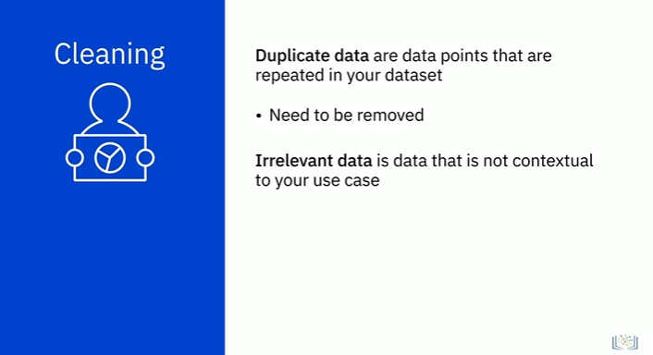

Data Type Conversion

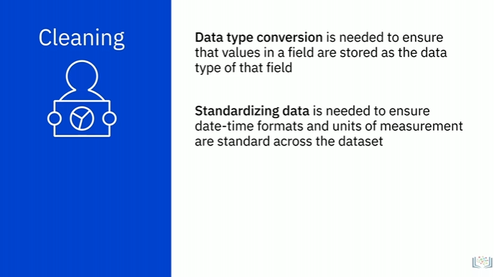

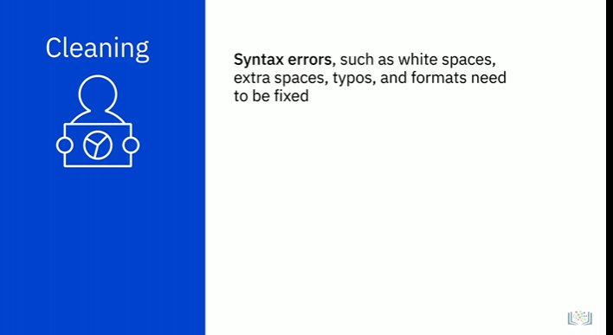

Outliner

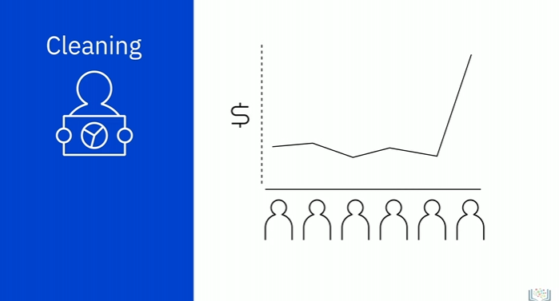

**Tools for Data Wrangling**

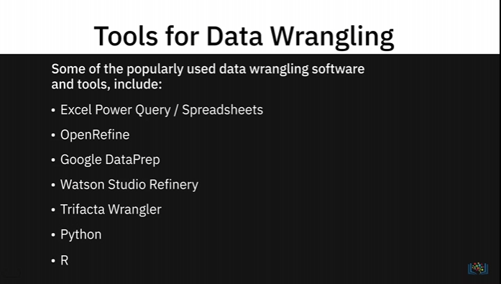

Excel Power Query/ Spreadsheet

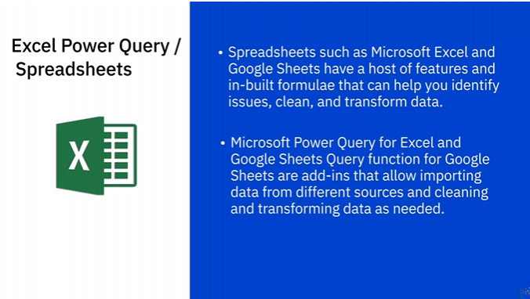

OpenRefine

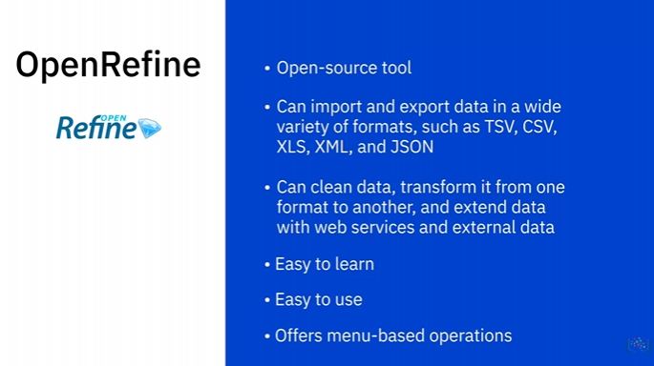

Google DataPrep

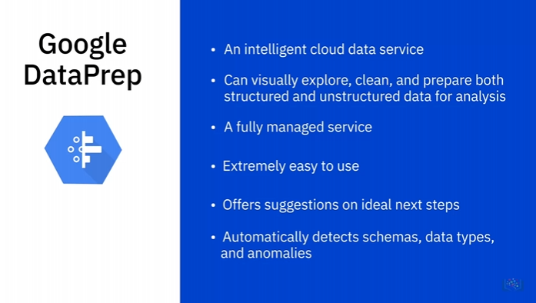

Watson Studio Refinery

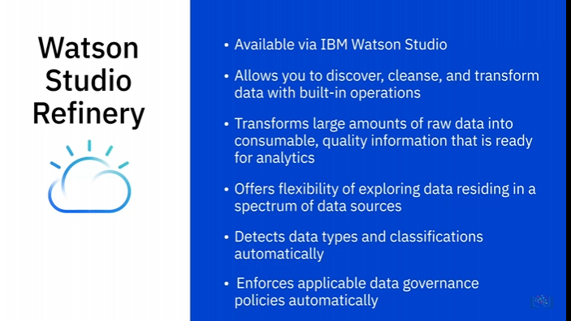

Trifacta Wrangler

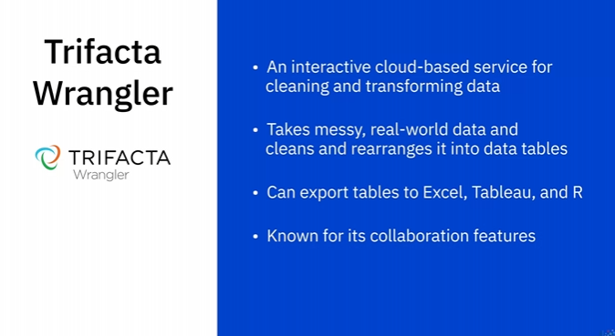

Python

Jupyter Notebook

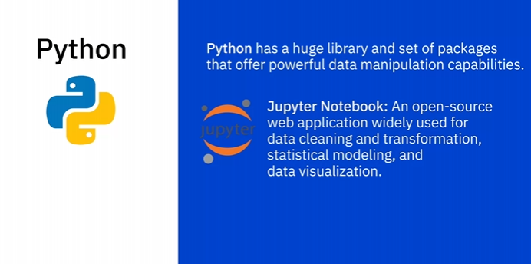

Numpy

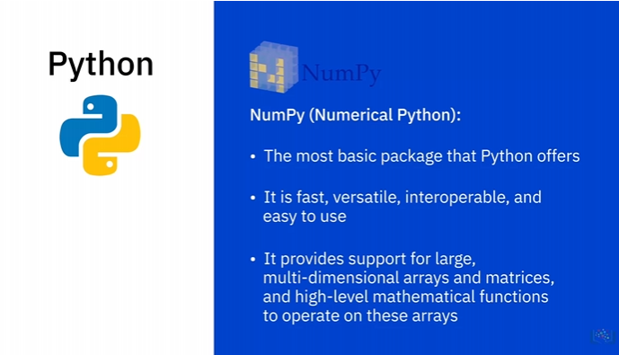

Pandas

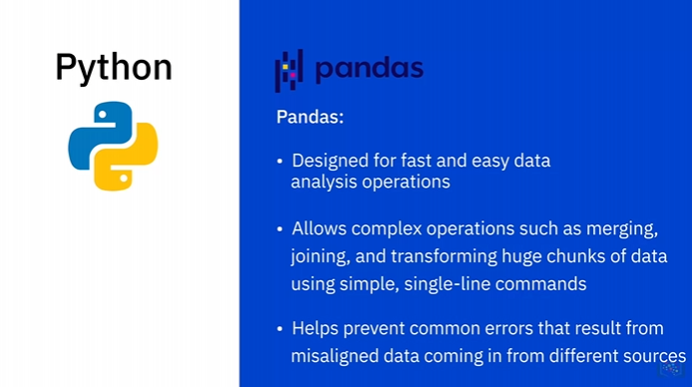

R

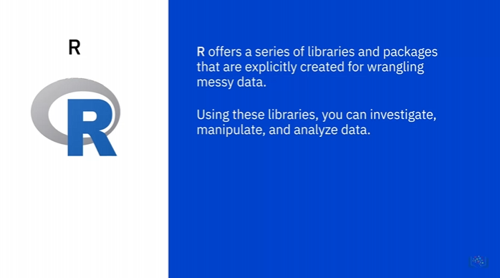

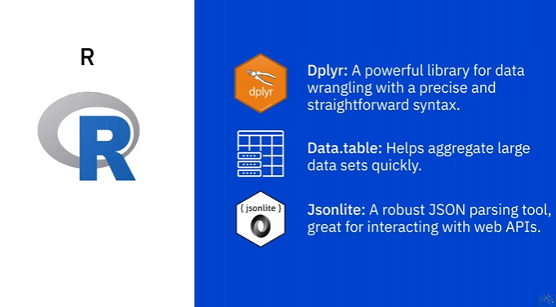

Tools for Data Wrangling

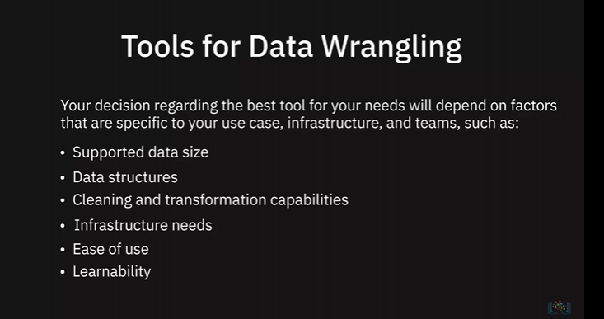

## Querying Data, performing tunning and troubleshooting

**Querying and Analyzing Data**

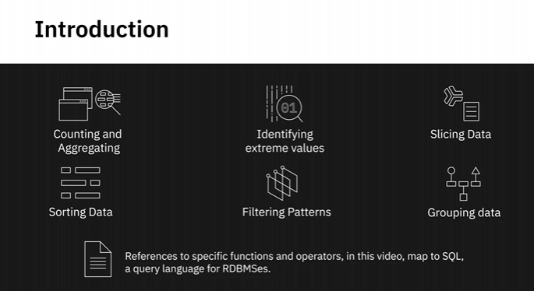

Counting

Example

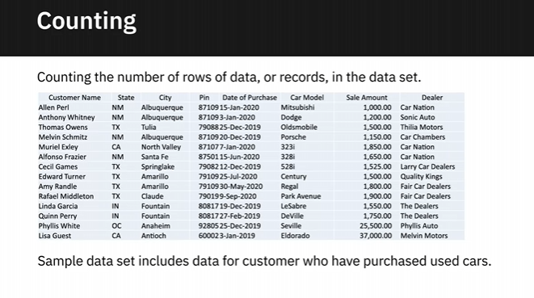

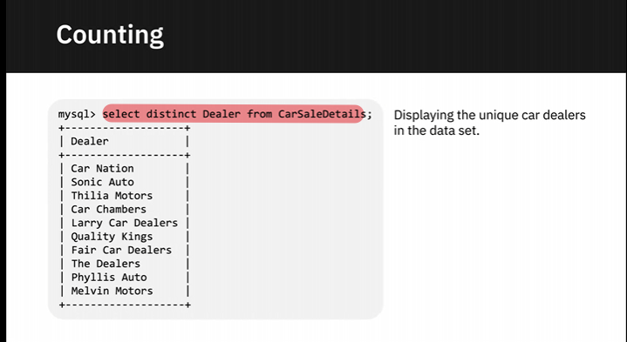

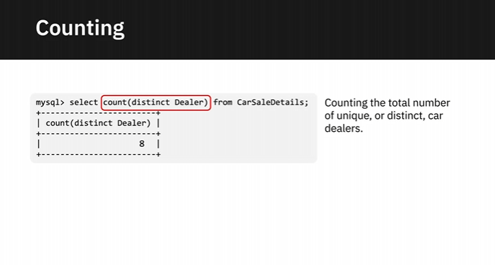

SELECT COUNT(DISTINCT Dealer) from CarSaleDetails;

Aggregation

